

**ソードアート・オンライン**

**SAO5e**

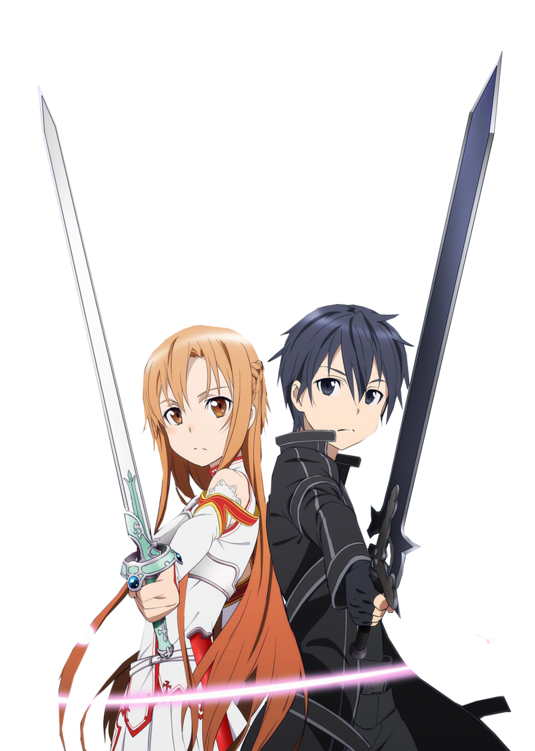

Fan made for…

**5e**

**TABLE OF CONTENTS**

**A Change of Rules… Pg3**

**Fighter Training… Pg4**

**A CHANGE OF RULES**

**Proficiency**

This is the greatest change in this adaption of 5e. Starting proficiency is completely removed and must be acquired via Quests, Training or sometimes even by drops. Proficiency bonus is also renamed to just Bonus.

**Ability Scores**

As you may have guessed, classes are reworked and can be found later on in this document as the base 5e classes don’t exactly fit the world, with this Ability Score Increases are also changed in the class. As SAO is an MMORPG, all players start with 10 in every ability score and can increase it as they level up. As well as this, the option to choose a feat instead of an Ability Score Increase is no longer allowed. Feats can be found as quest rewards or loot.

**Permadeath**

Permadeath means that there are no more death saving throws. SAO is a death game and once your HP hits 0, you die for good and since SAO has no means of spellcasting, there are no ways to resurrect dead players. Of course, a DM can ignore this rule since it may add extra pressure but in order to properly immerse yourself in the world of Aincrad, it is advised you leave this as it is.

**Level Cap**

The normal Level cap for 5e is level 20 as long as your DM isn’t allowing multiclass after level 20; in SAO5e this level cap is extended to level 100 since you are playing an MMORPG. The reason for this huge increase is for you to take advantage of Skill Points (which will be explained later) and for you to be able to increase each ability score to 20.

**Bonus Action**

In regular 5e you can use certain actions such as disengage, dodge etc. In SAO5e there are a few more actions you can take to reduce your chance of dying.

Switch: You take a bonus action and allow an ally within 20 feet to move up to their movement speed towards an enemy which is attacking you, for each 5ft your ally moves, you may move 5ft away from the enemy which is attacking you not provoking an opportunity of attack.

Taunt: You use a reaction and attempt to get the attention of an enemy within 30ft of you who has attacked an ally at least once. You try to get them to lose interest in who they are originally attacking making them roll a DC10 Intelligence Saving Throw.

Drive: You can use a bonus action to use a healing crystal or antidote crystal on yourself or an action to use it on an ally within 10ft of you.

**Races**

Every player must be a human however they get no features from the human race.

**Skill Points**

Skill points are received once per level and are detailed in the Skill points section of the document.

**TRAINING (class)**

In SAO5e the title of class is changed to training because anyone can train in any class no matter their level or skills. Multiclassing works slightly differently to regular 5e, you begin at level 1 in a class of your choosing and if you wish to try out another class, you only gain Ability Score Improvements or Skill Points from your highest level training, for example if I am training in Fighter and am level 15 but I am also a level 8 Beast Tamer, when I decide to level up Beast Tamer, I don’t get a skill point or Ability Score Improvement however when I decide to level up my Fighter training, I do because it is the higher level training. This means that a single character can only reach an ability score of 20 in 4 different ability scores and can only ever receive 100 skill points. Health also only increases when you level up your main class.

**Fighter**

A fighter is a player who decided to work their melee combat and ranged combat ability, a good fighter will usually join the front lines rather than hide away on the lower floors. A fighter screams courage and is destine to inspire others and put up more than just a good fight.

You can make a fighter quickly by following these suggestions. First, make Strength or Dexterity your highest ability score, depending on whether you want to focus on melee weapons or on archery (or finesse weapons). Your next-highest score should be Constitution.

**The Fighter Table**

|  |  |  |
| --- | --- | --- |
| **Level** | **Feature** | **Bonus** |
| 1 | Fighting Style |  |
| 2 |  |  |
| 3 | Ability Score Improvement |  |
| 4 |  |  |
| 5 |  |  |
| 6 | Ability Score Improvement |  |
| 7 | Second Wind |  |
| 8 |  |  |
| 9 | Ability Score Improvement |  |
| 10 |  | +1 |
| 11 |  |  |
| 12 | Ability Score Improvement |  |
| 13 | Indomitable |  |
| 14 |  |  |
| 15 | Ability Score Improvement |  |
| 16 |  |  |
| 17 |  |  |
| 18 | Ability Score Improvement |  |
| 19 |  |  |
| 20 | Fighting Style | +2 |
| 21 | Ability Score Improvement |  |
| 22 |  |  |
| 23 | Martial Archetype |  |
| 24 |  |  |
| 25 |  |  |
| 26 | Action Surge |  |
| 27 | Ability Score Improvement |  |
| 28 |  |  |
| 29 | Martial Archetype |  |
| 30 |  | +3 |
| 31 |  |  |
| 32 | Indomitable |  |
| 33 | Ability Score Improvement |  |
| 34 |  |  |
| 35 |  |  |
| 36 | Martial Archetype |  |
| 37 |  |  |
| 38 |  |  |
| 39 | Ability Score Improvement |  |
| 40 | Fighting Style | +4 |
| 41 | Indomitable |  |
| 42 |  |  |
| 43 |  |  |
| 44 |  |  |
| 45 | Ability Score Improvement |  |
| 46 | Martial Archetype |  |
| 47 |  |  |
| 48 |  |  |
| 49 |  |  |
| 50 |  | +5 |
| 51 | Ability Score Improvement |  |
| 52 |  |  |
| 53 | Martial Archetype |  |
| 54 |  |  |
| 55 |  |  |
| 56 | Extra attack |  |
| 57 | Ability Score Improvement |  |
| 58 |  |  |
| 59 |  |  |
| 60 |  | +6 |
| 61 | Fighting Style |  |
| 62 |  |  |
| 63 | Ability Score Improvement |  |
| 64 |  |  |
| 65 |  |  |
| 66 |  |  |
| 67 | Extra attack |  |
| 68 |  |  |
| 69 | Ability Score Improvement |  |
| 70 |  | +7 |
| 71 |  |  |
| 72 |  |  |
| 73 |  |  |
| 74 |  |  |
| 75 | Ability Score Improvement |  |
| 76 | Extra attack |  |
| 77 |  |  |
| 78 |  |  |
| 79 |  |  |
| 80 | Fighting Style | +8 |
| 81 | Ability Score Improvement |  |
| 82 |  |  |
| 83 |  |  |
| 84 |  |  |
| 85 |  |  |
| 86 | Extra attack |  |
| 87 | Ability Score Improvement |  |
| 88 |  |  |
| 89 |  |  |
| 90 |  | +9 |
| 91 |  |  |
| 92 |  |  |
| 93 | Ability Score Improvement |  |
| 94 | Action Surge |  |
| 95 |  |  |
| 96 |  |  |
| 97 |  |  |
| 98 |  |  |
| 99 | Ability Score Improvement |  |
| 100 | Mastery | +10 |

**Hit Points**

Hit dice: 1d10 per fighter level

Hit Points at 1st Level: 12

Hit Points at Higher Levels: 1d10 (or 6) + your Constitution modifier per fighter level after 1st

**Weapon Proficiency**

Fighters gain proficiency in either a Shortsword or a Shortbow.

**Equipment**

(a) Flimsy Shortbow, and 20 Wooden Arrows (b) Rusty Shortsword

(a) a dungeoneer’s pack or (b) an explorer’s pack

**Fighting Style**

You adopt a particular style of fighting as your specialty. Choose one of the following options. You can’t take a Fighting Style option more than once, even if you later get to choose again.

**Archery**

You gain a +2 bonus to attack rolls you make with ranged weapons.

**Defence**

While you are wearing armour, you gain a +1 bonus to AC

**Duelling**

When you are wielding a melee weapon in one hand and no other weapons, you gain a +2 bonus to damage rolls with that weapon.

**Great Weapon Fighting**

When you roll a 1 or 2 on a damage die for an attack you make with a melee weapon that you are wielding with two hands, you can reroll the die and must use the new roll, even if the new roll is a 1 or a 2. The weapon must have the two-handed or versatile property for you to gain this benefit.

**Protection**

When a creature you can see attacks a target other than you that is within 5 feet of you, you can use your reaction to impose disadvantage on the attack roll. You must be wielding a shield.

**Two-Weapon Fighting**

When you engage in two-weapon fighting, you can add your ability modifier to the damage of the second attack.

**Close Quarters Shooter (UA)**

When making a ranged attack while you are within 5 feet of a hostile creature, you do not have disadvantage on the attack roll. Your ranged attacks ignore half cover and three-quarters cover against targets within 30 feet of you. You have a +1 bonus to attack rolls on ranged attacks.

**Thrown Weapon Fighting (UA)**

You can draw a weapon that has the thrown property as part of the attack you make with the weapon.  
In addition, when you hit with a ranged attack using a thrown weapon, you gain a +1 bonus to the damage roll.

**Unarmed Fighting (UA)**

Your unarmed strikes can deal bludgeoning damage equal to 1d6 + your Strength modifier. If you strike with two free hands, the d6 becomes a d8.  
When you successfully start a grapple, you can deal 1d4 bludgeoning damage to the grappled creature. Until the grapple ends, you can also deal this damage to the creature whenever you hit it with a melee attack.

**Second Wind**

You have a limited well of stamina that you can draw on to protect yourself from harm. On your turn, you can use a bonus action to regain hit points equal to 1d10 + your fighter level.

Once you use this feature, you must finish a short or long rest before you can use it again.

**Action Surge**

Starting at 26th level, you can push yourself beyond your normal limits for a moment. On your turn, you can take one additional action on top of your regular action and a possible bonus action.

Once you use this feature, you must finish a short or long rest before you can use it again. Starting at 94th level, you can use it twice before a rest, but only once on the same turn.

**Indomitable**

Beginning at 13th level, you can reroll a saving throw that you fail. If you do so, you must use the new roll, and you can't use this feature again until you finish a long rest.

You can use this feature twice between long rests starting at 32nd level and three times between long rests starting at 41st level.

**Extra Attack**

Beginning at 56th level, you can attack twice, instead of once, whenever you take the Attack action on your turn.

The number of attacks increases to three when you reach 67th level in this class and to four when you reach 86th level in this class.

**Martial Archetypes**

Archetypes are plenty in number and it is up to your DM to tailor the archetype you wish to choose to this setting. Spellcasting based archetypes are automatically ruled out.

**Equipment & Tiers**

**Class**

F – Typical Starter equipment and the most common monster drops, item drops that are F class can normally be crafted into an item that is a tier higher.

Typical Cost: 1 – 100cor

E – Equipment of this calibre can acquired in the first to the 10th floor, uncommon monster drops on lower floors are normally of this tier.

Typical Cost: 100 – 500cor

D – Small guilds generally have gear of this quality when they have reached the 15th floor, gear of this tier is usually used for lower floor boss raids. Monster drops are generally this tier on floor 40-50 and are considered rare on floors beneath that.

Typical Cost: 500 – 5000cor

C – Raid parties generally use gear of this tier on the middle floors, D class materials will almost always create C class items. Monster drops will rarely be this tier on floors below floor 50.

Typical Cost: 5000 – 50,000cor

B – Highly skilled player use this tier equipment and it can be acquired from skilful crafting of high tier materials. B class monster drops are common on floor 80 but can be found very rarely around floor 60.

Typical Cost: 50,000 – 150,000cor

A – The best players in the game will carry gear this strong, A class gear is hard to craft even from using B class materials. This is the highest class of equipment that can drop from non-boss monsters. A class gear drops very rarely around floor 60 and becomes common on floor 90.

Typical Cost: 150,000 – 500,000cor

S – S class items are extremely rare around floor 70 and is almost never found on floors below it, however some have players have found S class items on lower floors even as low as floor 30. S class gear cannot be dropped by monsters however they can be crafted with A class materials when combined with other S class materials or alternatively be dropped from some floor bosses.

Typical Cost: 1,000,000cor+

SS – Items of SS rarity can only be found above the 75th floor on extremely rare occasions and sometimes on floor bosses from floor 90 and up. SS class gear can only be crafted solely using S class materials by a master blacksmith.

Typical Cost: N/A

**Cor**

Cor (Coin of Radius) is the currency in Aincrad. The value of Cor looks like this:

|  |  |
| --- | --- |
| Coin | Value (Cor) |
| Copper | 1 |
| Silver | 100 |
| Gold | 500 |
| Platinum | 100,000 |
| Mega | 1,000,000 |
| Giga | 1,000,000,000 |

Examples of prices of items can be found here:

1 Cor - The cheapest dry and unrefined black bread.

5 Cor - The price of an edible fruit dropped by trees in the Town of Beginnings.

10 Cor - The price for an NPC to lead a player to Algade's main plaza if they are lost.

10 Cor - The price of a cup of fire-breathing popcorn, sold during Heathcliff and Kirito's duel.

12 Cor - The price of a panini.

30 Cor - The amount of Cor that can be obtained by defeating a single Frenzy Boar in the field.

50 Cor - The price of renting a room in a 1st Floor inn for one night Comes with one bed and a table.

50 Cor - The price for a one-time use of a gondola that can fit two people in Rovia on the 4th Floor.

80 Cor - The price of renting the second floor of an NPC farmer's house in Tolbana for one night. Comes with two rooms, a large bedroom with a good view, a bathroom, and free milk.

100 Cor - The estimated daily rent for a guest room in the Town of Beginnings's church.

100 Cor - The cost of Lisbeth polishing Asuna's rapier.

180 Cor - The amount of Cor that can be obtained by defeating a Killer Mantis in the field.

1,000 Cor - The amount of Cor that can be obtained by defeating a Lizardman Lord on the 74th Floor.

16,000 Cor - The price of a new Anneal Blade a few days after the 1st Floor was cleared.

100,000 Cor - The estimated minimum purchase price for the S class Ragout Rabbit's Meat.

100,000 Cor - The minimum price of a custom-made weapon made using special ingredients by Lisbeth.

1,000,000 Cor (1 Mega Cor) - The cost of a "fairly spacious place" in a neighbourhood of Mishe, the main town of the 35th Floor.

1,000,000 Cor (1 Mega Cor) - The cost of a glass of rare wine.

3,000,000 Cor (3 Mega Cor) - The cost of a support-class small house with a waterwheel in Lindarth, a town on the 48th floor.

4,000,000 Cor (4 Mega Cor) - The cost of Asuna's furnished house in Selmburg, a town on the 61st floor.

5,000,000 Cor (5 Mega Cor) - A log house on the 22nd Floor.

1,000,000,000 Cor (1 Giga Cor) - Said to be the cost of the Knights of the Blood's headquarter tower on the 55th Floor.

**Materials**

**Ingots & Similar**

Cotton, 1cor/kg F

Hide, 5cor/kg F

Leather, 10cor/kg F

Wood, 20cor/log F

Copper, 20cor/bar F

Bronze, 25cor/bar F

Tin, 30cor/bar F

Iron, 50cor/bar F

Steel, 100cor/bar E

Bone, 200cor/kg E

Silver, 500cor/bar D

Titanium, 750cor/bar D

Platinum, 1000cor/bar C

Adamantine, 2000cor/bar C

Cold Tin, 2500cor/bar C

Orichalum, 5000cor/bar B

Cold Iron, 5500cor/bar B

Ebony, 8000cor/bar B

Cold Steel, 10,000cor/bar A

Blue Steel, 15,000cor/bar A

Uranium, 30,000cor/kg A

Meteor, 40,000cor/kg A

Black Steel, 50,000cor/bar S

Mithril, 100,000cor/bar S

Quicksilver, 500,000cor/bar S

Ithildin, 1,000,000cor/bar SS

**Gems**

Jasper

Opal

Quartz

Malachite

Jade

Amber

Lapis lazuli

Amethyst

Topaz

Sapphire

Emerald

Ruby

Diamond